Software Requirement Specifications

Version: [1.9]

Project ID | F25-269
Supervisor | Dr. Shahbaz Siddiqui
Co Supervisor | -
Project Team
Submission Date

Document History

Version | Name of Person | Date | Description of Change
1.0 | Alishba Hassan | 09/13/25 | Document Created
1.1 | Nimil Zubair | 10/18/25 | Introduction and Project Overview completed
1.2 | Ayesha Nasir | 10/27/25 | Project Scope, Not in Scope, and System Overview updated
1.3 | Alishba Hassan | 10/30/25 | System Constraints, External Interfaces, and Assumptions completed
1.4 | Nimil Zubair | 11/03/25 | Use Case Diagram added; Functional & Non-Functional Requirements completed
1.5 | Ayesha Nasir | 11/15/25 | Use Case Tables for Patient and Bank added
1.6 | Alishba Hassan | 11/20/25 | Use Case Tables for Hospital and Blockchain Module added
1.7 | Nimil Zubair | 11/30/25 | Admin Use Case Tables and Role Descriptions completed
1.8 | Ayesha Nasir | 12/01/25 | Updated Subscription and Token Management sections; full document review completed
1.9 | Alishba Hassan | 12/03/25 | Added Version History, Updated Diagrams, and Proofreading

Distribution List

Name | Role
Dr. Shahbaz Siddiqui |  | Supervisor
- |  | Co- Supervisor

Document Sign-Off

Version | Sign-off Authority | Sign-off Date
1.9 | Supervisor | 12/04/2025

Table of Contents

1. Introduction 6
1.1. Purpose of Document 6
1.2. Intended Audience 6
1.3 Abbreviations 6
1.4. Document Convention 6
2. Overall System Description 7
2.1. Project Background 7
2.2. Project Scope 7
2.3. Not In Scope 8
2.4. Project Objectives 9
2.5. Stakeholders 9
2.6. Operating Environment 9
2.7. System Constraints 10
2.8. Assumptions & Dependencies 10
2.9. Dependencies 10
3. External Interface Requirements 11
3.1. Hardware Interfaces 11
3.2. Software Interfaces 11
3.3. Communications Interfaces 12
4. Functional Requirements 13
4.1. Functional Hierarchy 13
4.1.1. Use Cases 13
5. Non-functional Requirements 23
5.1. Performance Requirements 23
5.2. Safety Requirements 23
5.3. Security Requirements 23
5.4. User Documentation 23
6. References 24
7. Appendices 25

- Introduction

  - Purpose of Document
The purpose of this Software Requirements Specification (SRS) is to provide a detailed and structured overview of the complete functional and non-functional requirements for the Fixed Assets Trading Platform.
This system introduces a modern mechanism where patients can deposit fixed assets (such as gold, silver) or participate through monthly healthcare subscriptions. These assets are tokenized into digital Asset Tokens (AT) using blockchain, enabling hospitals to invest or trade these tokens. Profits generated from these investments are distributed back to patients as Health Tokens (HT), which can be redeemed for healthcare benefits such as insurance coverage, OPD discounts, medication vouchers, etc.
This document ensures:
- Clear communication among all stakeholders
- Proper alignment of system requirements with business objectives
- Reference material for developers, testers, and project supervisors
- Defined scope, constraints, and system expectations
- A shared understanding of the technology stack, including blockchain + hospital/bank integration

  - Intended Audience
- Fast NU
- Jury
- Supervisor (Dr. Shahbaz Siddiqui)
- Project Team
- Future Developers
- Blockchain/Healthcare IT Teams
- Hospital Administrators (potential users)
- Banks/Financial partners (custodian role)
1.3 Abbreviations
- HOD = Head Of Department
- AT = Asset Token
- HT = Health Token
- API = Application Programming Interface
- DApp = Decentralized Application
- NFT = Non-Fungible Token (if assets need identification)
- OPD = Outpatient Department
- FYP = Final Year Project
- KPI = Key Performance Indicators
- DBMS = Database Management System
  - Document Convention
- Font Family = Arial
- Font Size = 14 and 12 for headings, 10 for the rest of the content
- Overall System Description
  - Project Background
The healthcare industry faces two major problems:
- Patients struggle with high upfront treatment costs, lack of financing options, and unreliable insurance systems.
- Hospitals face liquidity challenges and operate under traditional billing models with no innovative revenue channels.
There is no existing mechanism that:
- Allows patients to deposit real-world assets (gold, monetary value) to receive healthcare benefits
- Allows hospitals to generate revenue through trading/investment using tokenized assets
- Ensures transparency through blockchain for all parties involved
To solve these issues, our system introduces an Fixed Asset Trading Platform where patients deposit assets, banks verify and hold them, hospitals mint Asset Tokens (AT), trade them through regulated markets, and distribute profits as Health Tokens (HT) back to patients.
This ensures:
- Transparent financial operations
- Mutually beneficial model for hospitals and patients
- Secure blockchain-backed tracking
- Verified asset custody through banks

Problem Statement:
- Patients struggle to afford medical expenses due to limited financial flexibility.
- Hospitals lack modern investment models to generate additional revenue.
- No structured system exists for assets-based healthcare funding.
- Traditional insurance lacks transparency and trust.
- No mechanism exists for transparent profit sharing or tokenized healthcare benefits.

  - Project Scope
The system aims to create a blockchain-based asset tokenization platform providing:
Included Functionalities:
Patient Portal
- Asset deposit request
- Tokenization status
- Real-time token balance
- Health Token benefits
- Subscription-based healthcare card
- Profit notifications
Hospital Portal
- Verify asset deposits
- Mint Asset Tokens
- Conduct trades via trading API
- Track profits
- Allocate Health Tokens to patients
Blockchain Ledger
- Store token transactions
- Immutable record of deposits & profits
- Smart contract-driven tokenomics
Excluded Functionalities:
Actual physical trading or stock market execution
- The system does not perform real trades on stock exchanges.
- All trading operations are simulated using APIs for demonstration.
Automated valuation of assets (gold, silver, etc.)
- The system only uses external API for collecting rate and gives to hospital/bank either to change or not.
- Asset valuation is verified by the hospital/bank and then entered into the system.
Real-world insurance claim automation
- The system does not process or settle medical insurance claims.
- Only benefit allocation through Health Tokens (HT) is included.
Automated bank-side verification of deposited assets
- The system does not verify gold purity, property documents, or asset authenticity.
- No integration with land registry or banking verification systems exists.
- All physical verification is handled manually by the bank, outside the system.
- The system only records the bank’s final verification status.

  - Not in Scope
- Physical verification of land, gold, silver — this is done manually by banks.
- Legal documentation and ownership transfer processes.
- Real-world vault operations.
  - Project Objectives
Patient Objectives
- Allow patients to deposit assets for healthcare benefits.
- Provide real-time transparency over tokenized value.
- Offer subscription-based healthcare benefits for patients without assets.
Hospital Objectives
- Convert assets into Asset Tokens using blockchain.
- Invest/mint tokens into regulated portfolios via APIs.
- Allocate profits transparently back to patients using Health Tokens.
Bank Objectives
- Verify asset authenticity.
- Act as a custodian and issuance authority.
- Confirm deposits before token minting.
System Objectives
- Ensure transparency using blockchain.
- Provide secure multi-role portals.
- Display token balance, profit shares, and trading activity.
- Guarantee immutable transaction logs.

  - Stakeholders
- Patients
- Hospital Administration
- Hospital Finance Department
- Bank Officials
- Blockchain Engineers
- System Developers
- Backend Developers
- Testers
- Supervisors
- Database Administrator
- Organization (Fast NU)

  - Operating Environment
- Web-based system
- Runs on desktops and mobile browsers
- Backend powered by Java + APIs
- Frontend: React/Next.js
- Blockchain: Polygon/Ethereum testnet
- Database: MongoDB/Supabase
- Secure bank-hospital integration API

  - System Constraints
- Blockchain confirmation time may cause delays (5–15 seconds) otherwise local deployed..
- All assets require bank verification before tokenization.
- Trading API restrictions (rate limits).
- Must maintain secure communication with bank and hospital servers.
- Internet connection required for real-time token balance and trading.

  - Assumptions & Dependencies
- Patients will provide truthful asset details.
- Banks will verify assets manually and accurately.
- Hospital finance staff will conduct trades responsibly.
- Users have basic knowledge of using web portals.

  - Dependencies
- Trading API availability
- Blockchain network availability
- Bank verification response
- Hospital system uptime
- Secure API integration

- External Interface Requirements
This section describes how the system interacts with external components such as hardware, software, communication protocols, and network services.
  - Hardware Interfaces
The system is web-based and requires minimal hardware resources. It will be accessed by patients, hospitals, and bank officials.
Supported Hardware:
- Desktop or Laptop Devices
  - Minimum 4GB RAM
  - Dual-core processor
  - Windows 10, macOS 10.13+, or Linux kernel 4.x+
- Mobile Devices
  - Any smartphone capable of running a modern browser
  - Minimum 2GB RAM
- Servers (Hospital + Blockchain Node)
  - Node running blockchain client (Polygon/Ethereum testnet)
  - Minimum 8GB RAM and stable internet for blockchain operations
  - Secure storage for hosting tokens & transaction logs
- General Requirement
  - Any device must have a web browser and stable internet access.
  - Software Interfaces
Database Interface: MongoDB / Supabase
- Stores patient data, token balances, deposit requests, benefits, subscription details, trading logs, and hospital activities.
- Data retrieval via REST APIs.
Blockchain Interface (Polygon/Ethereum)
- Smart contracts written in Solidity.
- Used for minting Asset Tokens (AT) and Health Tokens (HT).
- Used to record all transactions.
Trading API
- REST-based API for simulated investment/trading operations.
- Used only for generating profit/loss outcomes.
Bank Verification API (Simulated)
- Bank does NOT physically verify assets through system.
- Hospital updates verification status in system manually.
- API only receives the final “Verified/Rejected” status from bank.
Authentication System
- JWT-based authentication.
- Multi-factor login support for hospital and bank portals.
Frontend Interface
- React/Next.js application communicating with backend using JSON.

  - Communications Interfaces
- Communication Protocol: HTTPS
- Data Format: JSON
- Blockchain Communication
- API Calls: REST, secured with tokens
- Bank ↔ Hospital Communication: Secure encrypted API channel
- Automatic Sync:
- Trading data synced e
- Token balances updated automatically after each transaction

- Functional Requirements
  - Functional Hierarchy
1. Patient Functions
1.1 Submit Asset Deposit Request
1.2 View Token Balance (AT + HT)
1.3 Track Benefits (Discounts, Insurance, OPD)
1.4 View Hospital Trading Activities
1.5 View Subscription Card Details
1.6 Receive Notifications
2. Hospital Functions
2.1 Approve/Reject Asset Deposits
2.2 Mint Asset Tokens
2.3 Conduct Trades using Trading API
2.4 View Profit/Loss
2.5 Allocate Health Tokens to Patients
2.6 Manage Patient Accounts
3. Bank Functions
3.1 Verify Deposited Assets Manually
3.2 Update Verification Status in System
3.3 Act as Custodian of Real Assets
4. Blockchain Functions
4.1 Mint Asset Tokens (AT)
4.2 Mint Health Tokens (HT)
4.3 Record Transactions on Ledger
4.4 Provide Immutable History
5. Subscription & Health Card System
5.1 Monthly Subscription Payments
5.2 Conversion of subscription pool into AT
5.3 Annual benefits distribution
6. Admin Functions
6.1 Manage Users
6.2 Manage Hospital & Bank Roles
6.3 Monitor System Health

    - [Use Case Diagram]
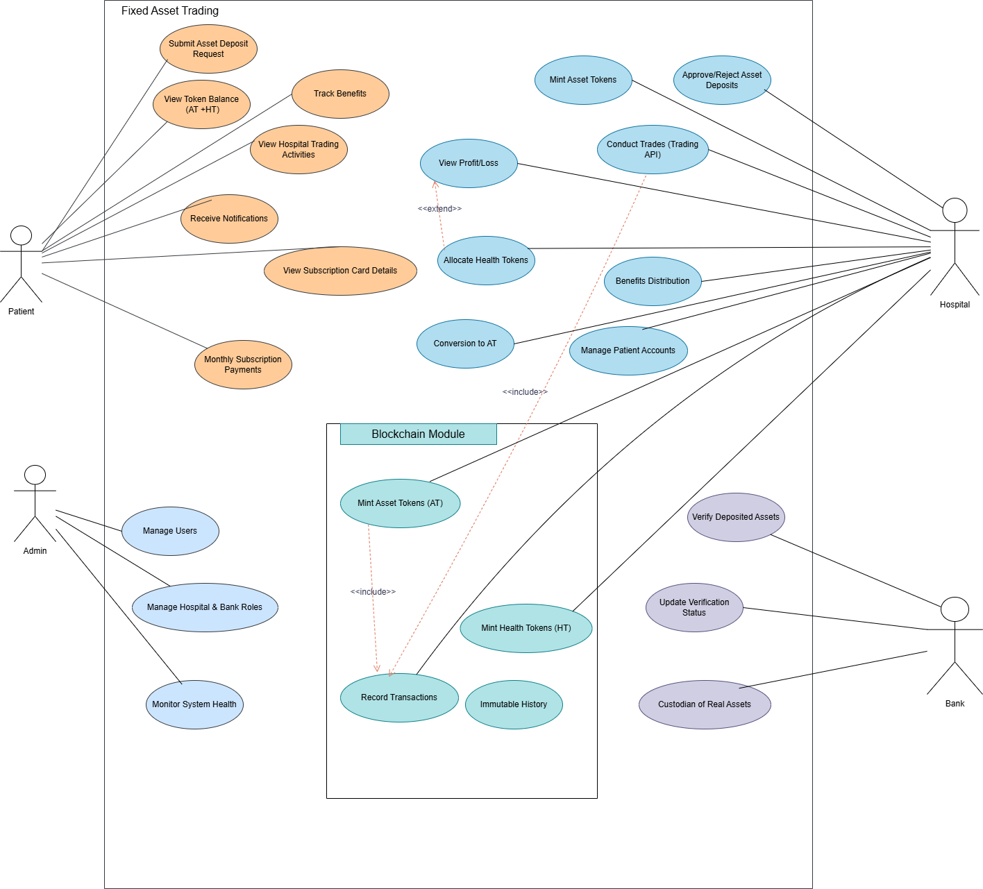

<UC-PATIENT -01 -Submit Asset Deposit Request>
Use case Id: |  | UC-PATIENT-01
Actors: : Patient
Feature: Submit Asset Deposit Request
Pre-condition: |  | • Patient must have a valid account.  • Patient must be logged in.  • Asset details (type, value, documents) must be available.
Scenarios
Step# | Action |  |  | Software Reaction
1. | Patient selects “Deposit Asset”. |  |  | System displays deposit form.
2. | Patient enters asset details. |  |  | System validates fields.
3. | Patient submits request. |  |  | Request forwarded to hospital.
Alternate Scenarios:
1a: Missing fields → system asks for correction.
2a: Invalid document → system requests re-upload.
Post Conditions
Step# | Description
1 | Request stored in system
2 | Status set to “Pending Verification”.
Use Case Cross referenced |  |  | UC-HOSPITAL-01  UC-BANK-01  UC-PATIENT-02

<UC-PATIENT -02-VIEW TOKEN BALANCE>
Use case Id: |  | UC-PATIENT-02
Actors: : Patient
Feature: View Token Balance (AT+HT)
Pre-condition: |  | • Patient logged in.  • Tokens must exist in blockchain.
Scenarios
Step# | Action |  |  | Software Reaction
1. | Patient selects “My Tokens”. |  |  | System retrieves balances
2. | Patient views history. |  |  | System displays AT + HT usage details.
Alternate Scenarios:
• 1a: No tokens → “No tokens found.”
Post Conditions
Step# | Description
1 | Patient views updated balance.
Use Case Cross referenced |  |  | UC-HOSPITAL-02  UC-HOSPITAL-04  UC-PATIENT-03

< UC-HOSPITAL-01 — Approve/Reject Deposits >
Use case Id: |  | UC-HOSPITAL-01.
Actors: Hospital.
Feature: Approve/Reject Asset Deposit Requests
Pre-condition: |  | • Patient request must exist.  • Hospital must be logged in.
Scenarios
Step# | Action |  |  | Software Reaction
1. | Hospital logs in. |  |  | Dashboard displayed.
2. | Opens “Pending Deposits”. |  |  | Request list shown..
3. | Reviews documents. |  |  | Details displayed.
4. | Approve/Reject. |  |  | Status forwarded to bank.
Alternate Scenarios:
• 1a: Wrong credentials → error.
• 2a: No pending requests → “No pending deposits.”
Post Conditions
Step# | Description
1. | Request marked approved/rejected.
2. | Bank receives verification request.
Use Case Cross referenced |  |  | - UC-BANK-01,  - UC-HOSPITAL-02  - UC-PATIENT-01

<UC-BANK-01 — Bank Manual Verification >
Use case Id: |  | UC-BANK-01
Actors: Bank Officer
Feature: Manual verification of Assets

Pre-condition: |  | • Hospital must approve request.  • Asset must be physically available for inspection.
Scenarios
Step# | Action |  |  | Software Reaction
1. | Bank receives verification request. |  |  | System displays details.
2. | Bank verifies asset physically. |  |  | (External manual step)
3. | Bank updates verification result. |  |  | System stores final status.
Alternate Scenarios:
• 2a: Asset fails verification → Bank selects “Rejected”.

Post Conditions
Step# | Description
  1
  Status updated to Verified/Rejected.
  2
  Hospital notified.
Use Case Cross referenced |  |  | UC-HOSPITAL-02  UC-HOSPITAL-01

<UC-HOSPITAL-02 — Mint Asset Tokens (AT) >
Use case Id: |  | UC-HOSPITAL-02
Actors: Hospital.
Feature: Mint Asset Tokens (AT)
Pre-condition: |  | • Bank must verify the asset.  • Smart contract must be active.  • Hospital must be logged in.
Scenarios
Step# | Action |  |  | Software Reaction
1. | Hospital checks verification status. |  |  | System shows “Verified”.
2. | Hospital clicks “Mint Tokens”. |  |  | Smart contract mints Asset Tokens.
3. | Tokens added to hospital wallet. |  |  | Ledger updated.
Alternate Scenarios:
• 1a: Verification not completed → “Cannot mint tokens.”

Post Conditions
Step# | Description
1. | AT successfully minted.
2. | Patient’s AT record updated.
Use Case Cross referenced |  |  | UC-HOSPITAL-03  UC-PATIENT-02  UC-BANK-01

<UC-HOSPITAL-03 — Conduct Trade via Trading API >
Use case Id: |  | UC-HOSPITAL-03
Actors: Hospital Trader / System
Feature: Conduct Trades using Trading API
Pre-condition: |  | • Hospital must have AT balance.  • Trading API must be active.  • Hospital must be logged in.
Scenarios
Step# | Action |  |  | Software Reaction
1 | Hospital selects “Trade”. |  |  | System displays trading interface.
2 | Hospital enters trade amount. |  |  | System validates input.
3 | Hospital confirms trade. |  |  | API executes trade.
4 | Trade completed. |  |  | Profit/Loss recorded in system.
Alternate Scenarios:
• 2a: Invalid amount → system prompts correction.
• 3a: API failure → system shows “Trade Failed”.
Post Conditions
Step# | Description
1. | Trade stored on ledger simulation.
2. | Updated profit/loss shown in hospital dashboard.
Use Case Cross referenced |  |  | UC-HOSPITAL-04  UC-PATIENT-02

<UC-HOSPITAL-04 — Assign Health Tokens (HT) >
Use case Id: |  | UC-HOSPITAL-04
Actors: :Hospital.
Feature: Assign Health Tokens to Patients
Pre-condition: |  | • System must have profit values.  • Hospital must be logged in.  • Patient account must exist.
Scenarios
Step# | Action |  |  | Software Reaction
1 | Hospital views total profit summary. |  |  | System displays profit data.
2 | Hospital selects patient. |  |  | Input field appears.
3 | Hospital enters HT amount. |  |  | System validates.
4 | Hospital confirms allocation. |  |  | Smart contract mints and transfers HT.
Alternate Scenarios:
• 3a: Invalid amount → system shows error.
Post Conditions
Step# | Description
1 | HT transferred to patient wallet.
2 | Updated benefits visible to patient.
Use Case Cross referenced |  |  | UC-PATIENT-03  UC-PATIENT-02  UC-HOSPITAL-03

<UC-PATIENT-03 — View & Redeem Benefits>
Use case Id: |  | UC-PATIENT-03
Actors: Patient
Feature: View and Redeem HT Benefits
Pre-condition: |  | • Patient must be logged in.  • Patient must have HT tokens.
Scenarios
Step# | Action |  |  | Software Reaction
1 | Patient clicks “Benefits”. |  |  | System shows redeemable benefits.
2 | Patient selects a benefit. |  |  | System shows required HT.
3 | Patient confirms redemption. |  |  | System deducts HT and confirms redemption.
Alternate Scenarios:
• 2a: Insufficient HT → “Not enough tokens.”
Post Conditions
Step# | Description
1 | HT deducted from patient wallet.
2 | Benefit marked redeemed.
Use Case Cross referenced |  |  | UC-PATIENT-02  UC-HOSPITAL-04

<UC-SUBSCRIPTION-01 — Monthly Subscription Conversion >
Use case Id: |  | UC-SUBSCRIPTION-01.
Actors: Patient, Hospital
Feature: Monthly Subscription Processing
Pre-condition: |  | • Patient subscription must be active.  • Payment gateway must send success status.
Scenarios
Step# | Action |  |  | Software Reaction
1. | Patient pays monthly subscription. |  |  | Payment added to subscription pool.
2. | Hospital converts pool amount → AT. |  |  | Ledger updated.
3. | System allocates monthly/annual benefits. |  |  | HT assigned to patients.
Alternate Scenarios:
• 1a: Payment failed → “Subscription payment failed.”
Post Conditions
Step# | Description
1. | AT minted from subscription pool.
2. | HT benefits distributed.
Use Case Cross referenced |  |  | UC-HOSPITAL-02  UC-HOSPITAL-04  UC-PATIENT-03

<UC-ADMIN-01 — Manage Users >
Use case Id: |  | UC-ADMIN-01
Actors: Admin
Feature: Manage Users (Add, Edit, Delete, View)
Pre-condition: |  | • Admin must be logged in.  • System roles must exist.
Scenarios
Step# | Action |  |  | Software Reaction
1. | Admin opens “User Management”. |  |  | System displays user list.
2. | Admin selects Add/Edit/Delete. |  |  | Corresponding form/action opens
3. | Admin submits new details/changes. |  |  | System validates and saves changes.
Alternate Scenarios:
• 2a: Edit user but invalid data → system shows “Invalid fields.”
• 3a: Delete user → system asks for confirmation.
Post Conditions
Step# | Description
1. | User information is updated.
2. | System stores audit logs of admin actions.
Use Case Cross referenced |  |  | UC-ADMIN-02  UC-ADMIN-03

<UC-ADMIN-02 — Manage Hospital & Bank Roles>
Use case Id: |  | UC-ADMIN-02
Actors: Admin
Feature: Manage Roles (Hospital, Bank, Patient, Trader)
Pre-condition:
  • Admin must be logged in.
  • User must exist in system.
Scenarios
Step# | Action |  |  | Software Reaction
1 | Admin opens “Role Management”. |  |  | System displays user role table.
2 | Admin updates role (Hospital/Bank/Patient/Admin). |  |  | System validates change.
3 | Admin confirms update. |  |  | System applies updated role.
Alternate Scenarios:
• 2a: Admin tries to update role to invalid type → error shown.
Post Conditions
Step# | Description
1. | Updated roles saved in system
2. | New permissions applied.
Use Case Cross referenced |  |  | UC-ADMIN-01  UC-ADMIN-03

<UC-ADMIN-03 — Monitor System Health>
Use case Id: |  | UC-ADMIN-03
Actors: Admin
Feature: Monitor System Health & System Operations
Pre-condition: |  | • Admin must be logged in.  • Monitoring dashboard must be active.
Scenarios
Step# | Action |  |  | Software Reaction
1 | Admin opens “System Monitoring”. |  |  | Dashboard displayed.
2 | Admin checks API connections. |  |  | System shows live status.
3 | Admin checks blockchain logs. |  |  | Immutable ledger entries displayed.
4 | Admin checks user activities. |  |  | Audit logs shown.
Alternate Scenarios:
• 2a: API down → system shows “Connection Failed”.
• 3a: Ledger unavailable → “Blockchain Node Unreachable”.
Post Conditions
Step# | Description
1. | Admin obtains real-time system status.
2. | Logs updated for future review.
Use Case Cross referenced |  |  | UC-ADMIN-01  UC-ADMIN-02

- Non-functional Requirements
  - Performance Requirements
- System must handle ~100+ concurrent users.
- Token minting must finalize within 10–15 seconds.
- API responses within 3 seconds.
- Dashboard loading within 2 seconds.
  - Safety Requirements
- No unauthorized access to token balances.
- Bank verification must be confirmed manually before token minting.
- Fail-safe triggers prevent duplicate trades.
- Daily backup of ledger and database.
  - Security Requirements
- Encryption for sensitive data.
- Blockchain smart contracts ensure immutability.
- Secure authorization for hospital and bank login.
- Role-based access control (RBAC).
- All APIs must use HTTPS.
  - User Documentation
- A User Manual will guide Patients, Hospital Staff, Bank Officers, and Admins through all system features including asset deposit, token management, trading operations, verification processes, and subscription handling.
- Integrated Online Help within the web application will provide step-by-step instructions for performing major tasks such as depositing an asset, approving a request, minting tokens, or allocating health benefits.
- Tutorial Videos will be available for complex operations, such as using the Trading API, minting Asset Tokens (AT) and Health Tokens (HT), or managing blockchain ledger entries.
- Context-Sensitive Help will automatically display relevant guidance based on the user’s current page—for example, help for “Mint Tokens” when the user opens the minting interface.
- A Troubleshooting Guide will assist users in resolving common issues such as failed login attempts, incorrect document uploads, rejected asset verification, or issues with benefit redemption.

- References
- Ethereum Documentation, Smart Contracts, 2024.
- Polygon Developer Docs, Token Standards, 2024.
- Healthcare Tokenization Models – IEEE Journals.
- Web3.js & Ethers.js Documentation.
- Financial Custodian Models – Banking Standards Publication.

- Appendices
- Appendix A: Tokenomics Models
- Appendix B: AT/HT Conversion Formula
- Appendix C: Sequence Diagrams
- Appendix D: Ledger Screenshots

